

June 19 & 20 2026

Dear Community Partner,
We’re excited to announce that planning for Oahe Days 2026 is already underway and we would love for you to be part of it!
Oahe Days continues to be one of the area’s favorite summer traditions, bringing our community together for a weekend filled with music, food, art, activities, and plenty of fun. Thanks to the incredible support of local businesses and individuals, last year’s festival was one of our most successful yet, and we’re aiming even higher for 2026!
As we prepare for another outstanding celebration, we’re inviting you to join us as a sponsor. Sponsorship is a meaningful way to support our community while gaining visibility for your business. Enclosed, you’ll find our 2026 sponsorship levels, each with its own set of benefits designed to help you connect with thousands of attendees throughout the weekend.
Not ready for a financial sponsorship? We still want you involved!
Our volunteer opportunities are included, offering many ways individuals or teams can contribute to making Oahe Days a smooth, engaging, and memorable experience for everyone.
Your support, whether as a sponsor, volunteer, or both, is what keeps Oahe Days thriving. Thank you for your consideration, your partnership, and your continued dedication to our community.
We look forward to collaborating with you for Oahe Days 2026!With appreciation,
The Oahe Days Planning Committee

Building Pride Through Community Celebration!
All of our sponsors will receive the following:
- Free advertisement on our Facebook page
- Free advertisement on our website, www.oahedays.com
____ $200 – $499- you will receive the above advertising.

____ Bronze Sponsor - $500 In addition to the above:
- Advertising on our posters, which will be posted throughout the area, the weeks leading up to Oahe Days.

____ Silver Sponsor - $750 You will receive the benefits above of a bronze sponsor plus:
- Your company name will be announced throughout the night

____ Gold Sponsor - $1,000 You will receive the benefits of a silver sponsor plus:
- Name on the back of T-shirts worn by volunteers throughout the weekend

____ Platinum Sponsor - $2,500 You will receive the benefits of a gold sponsor plus:
- The company will have a branded table spool, in/around the beverage garden.
- Your company’s logo will be featured in the Visit Pierre’s annual “Oahe Days” digital marketing campaign seen throughout the state
- You will receive 10 free drink tokens

____ Main Event Sponsor - $3,000 You will receive the benefits of a platinum sponsor:
- Your company will have the option to hang banners both on the main stage and in the beer garden.
- The company will have a 4’ X 4’ banner on the 53’ Reefer Trailer at the event.
- Advertisement on the front page of the website.
- Your company will receive 30 free drink tickets.

_____ Picnic Table Sponsor -$3,000 (Guaranteed for 3 years)
Picnic table sponsors receive all the benefits of a Platinum-Level Sponsor. Each table features a custom tabletop wrap designed specifically with your business in mind. Our designer will work with you to incorporate your name, logo, or branding to ensure a clean, professional, and appealing look.
Your picnic table sponsorship includes:
- A minimum three-year guarantee
- The initial custom-designed tabletop wrap
- Two additional re-wraps, as needed, at no additional cost
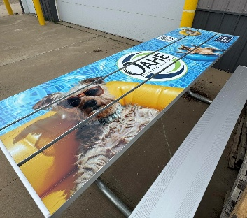
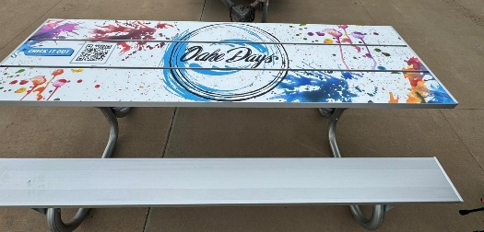
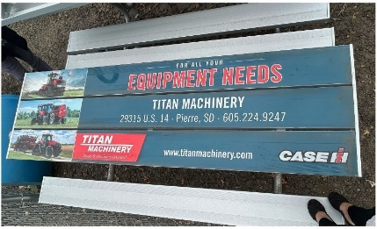

----------------------------------------------------------------------------
Oahe Days 2026 Sponsorship
PO Box 365 Pierre, SD 57501

Name of business __________________________________________________

Please invoice at a later date: _______________________

Date: __________ Sponsorship Level: $__________________ Phone: _________________

Check Number: ___________ Thank you for your support of Oahe Days!

Diamond, Picnic Table and Main Event Sponsors need to submit their logos by Friday, April 17, 2026, to allow ample time for order placement and table design for the event.
Volunteer Opportunities (Time slots can be in one (1) hour increments)
_____ Beer Garden (must be 21)
  - Serving drinks, managing the area, and ensuring attendees have a great experience.
_____ ID Checking at Beer Garden (must be 21)
  - Verifying IDs to ensure compliance with event regulations.
_____ Washing Tables from Food & Spill
  - Starting Friday at 6 pm.
  - Saturday Starting at 1 pm.
_____ Clean-Up Crew (Sunday) Starting at 9:00 am
  - Help tidy up and restore the area after the festivities are over.

Contact Information
Name: ___________________________________________________________
Phone Number: __________________________________________________
Email Address: ___________________________________________________
Additional Notes or Requests
____________________________________________________________________________________________________________________________________________________________________________________________________________________________________________________________________________
Thank you for volunteering!
We will be in touch with additional details and confirmation of your schedule. If you have any questions, please contact the Oahe Days committee at oahedays@gmail.com.

